BEGIN;

INSERT INTO students (name, age) VALUES ('Likhith', 22);

SAVEPOINT sp1;

INSERT INTO students (name, age) VALUES ('Test', 99);

ROLLBACK TO sp1;

COMMIT;

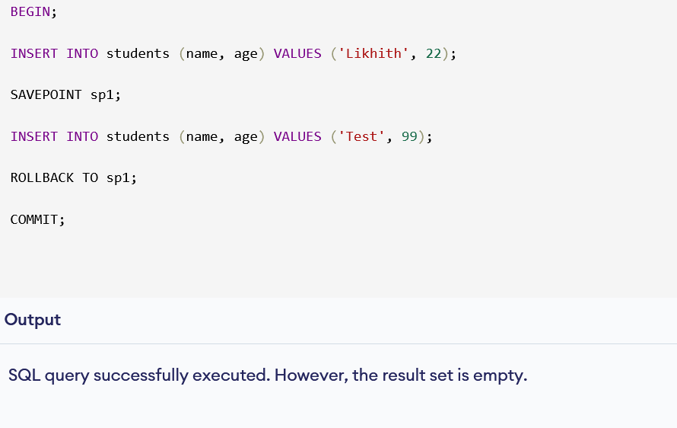

SELECT name, age + 5 AS age_in_5_years FROM students;

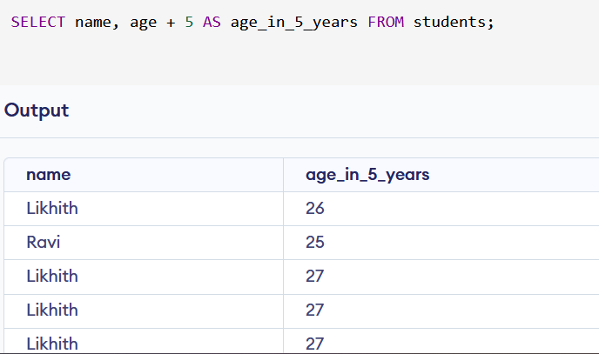

SELECT * FROM students WHERE age > 21;

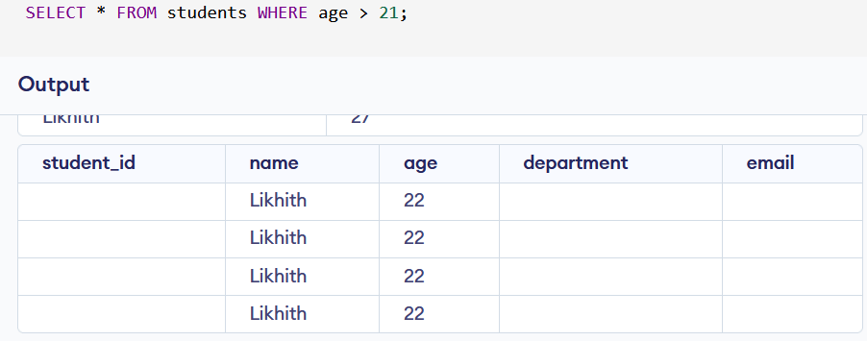

SELECT * FROM students WHERE name LIKE 'R%';

SELECT * FROM students WHERE age BETWEEN 20 AND 22;

